a. Load a CSV dataset. Handle missing values, inconsistent formatting, and outliers.
b. Load a dataset, calculate descriptive summary statistics, create visualizations using different graphs, and identify potential features and target variables
c. Create or Explore datasets to use all pre-processing routines like label encoding, scaling.

Code:
import pandas as pd
import numpy as np
import matplotlib.pyplot as plt
import seaborn as sns
from sklearn.preprocessing import LabelEncoder
from sklearn.preprocessing import StandardScaler
df = pd.read_csv("Churn_Modelling.csv")
df.shape
df.head()
df.tail()
df.info()
df.isnull().sum()
df.dropna()
df.isnull().sum()
df.duplicated().sum()
df.drop_duplicates()
df.duplicated().sum()
df.columns.str.strip()
df["Surname"] = df["Surname"].str.strip()
df["Gender"] = df["Gender"].str.strip()
df["Geography"] = df["Geography"].str.strip()
le = LabelEncoder()
df["Gender"] = le.fit_transform(df["Gender"])
df["Geography"] = le.fit_transform(df["Geography"])
df = df.drop(["RowNumber", "CustomerId", "Surname"], axis=1)
df.describe()
df.corr()
plt.figure(figsize=(8,5))
plt.hist(df["Age"], bins=20, color="skyblue", edgecolor="black")
plt.title("Age Distribution")
plt.xlabel("Age")
plt.ylabel("Frequency")
plt.show()
plt.figure(figsize=(7,5))
sns.barplot(x="Gender", y="Balance", data=df)
plt.title("Gender vs Average Balance")
plt.show()
plt.figure(figsize=(7,5))
plt.scatter(df["Age"], df["Balance"], color="blue")
plt.xlabel("Age")
plt.ylabel("Balance")
plt.title("Age vs Balance")
plt.show()
scaler = StandardScaler()
X=df.drop(“Exit”,axis=1)
X_scaled = scaler.fit_transform(X)
print("\nScaled Features")
print(X_scaled)

Simple Linear Regression

A. Fit a linear regression model on a dataset. Interpret coefficients, make predictions, and evaluate performance using metrics like R-squared and MSE

Code:
import pandas as pd
import numpy as np
from sklearn.datasets import fetch_california_housing
from sklearn.model_selection import train_test_split
from sklearn.linear_model import LinearRegression
from sklearn.metrics import mean_squared_error, r2_score

housing = fetch_california_housing()

df = pd.DataFrame(housing.data, columns=housing.feature_names)
df["Price"] = housing.target

print("Dataset:")
print(df.head())

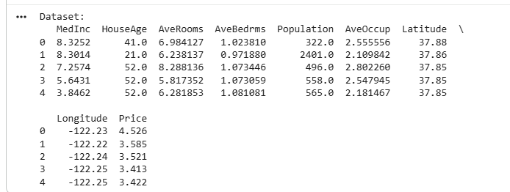

X = df.drop("Price", axis=1)
y = df["Price"]

X_train, X_test, y_train, y_test = train_test_split( X, y, test_size=0.2, random_state=42)
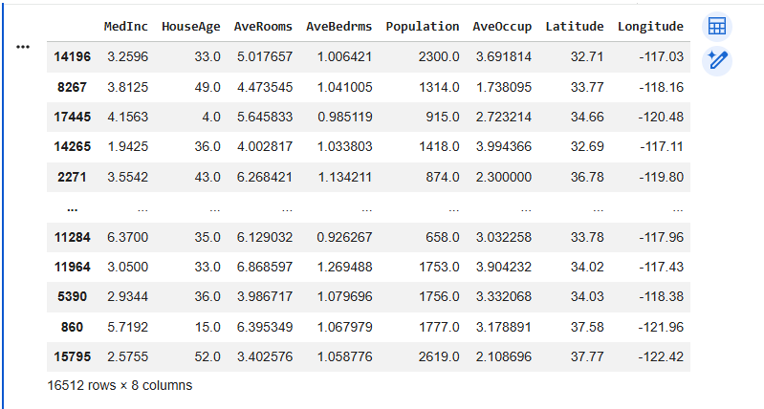

model = LinearRegression()

model.fit(X_train, y_train)

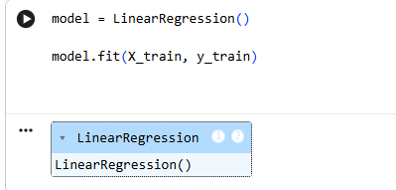

y_pred = model.predict(X_test)

print("\nIntercept:")
print(model.intercept_)

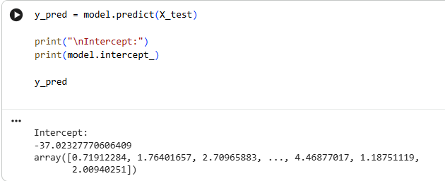

mse = mean_squared_error(y_test, y_pred)
r2 = r2_score(y_test, y_pred)
y_pred

print("\nMean Squared Error (MSE):", mse)
print("R-squared Score:", r2)

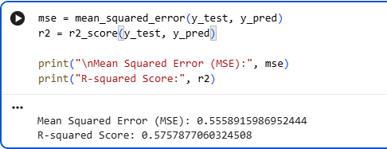

Aim: Perform binary classification using logistic regression. Calculate accuracy, precision, recall,
and understand the ROC curve.

import matplotlib.pyplot as plt
from sklearn.datasets import load_breast_cancer
from sklearn.model_selection import train_test_split
from sklearn.linear_model import LogisticRegression
from sklearn.metrics import accuracy_score, precision_score, recall_score, roc_curve, roc_auc_score

data = load_breast_cancer()
X = data.data
y = data.target

X_train, X_test, y_train, y_test = train_test_split(
X, y, test_size=0.2, random_state=42
)

model = LogisticRegression(max_iter=5000)
model.fit(X_train, y_train)

y_pred = model.predict(X_test)
y_prob = model.predict_proba(X_test)[:, 1]

print("Accuracy:", round(accuracy_score(y_test, y_pred), 3))
print("Precision:", round(precision_score(y_test, y_pred), 3))
print("Recall:", round(recall_score(y_test, y_pred), 3))

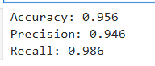

fpr, tpr, thresholds = roc_curve(y_test, y_prob)
auc = roc_auc_score(y_test, y_prob)

plt.plot(fpr, tpr, label="ROC Curve (AUC = %.2f)" % auc)
plt.plot([0, 1], [0, 1], "k--", label="Random Classifier")

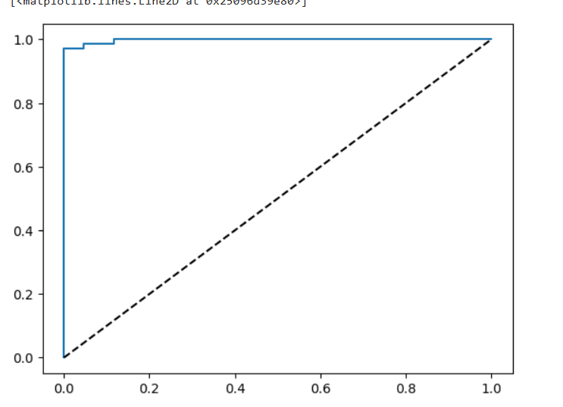

plt.xlabel("False Positive Rate")
plt.ylabel("True Positive Rate")
plt.title("ROC Curve - Logistic Regression")
plt.legend()
plt.show()

print("AUC Score:", round(auc, 3))
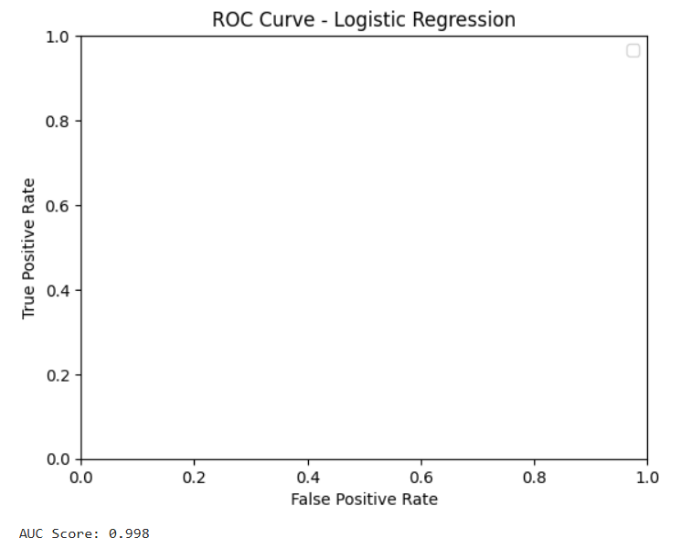

Aim: Implement a Support Vector Machine for any relevant dataset.

import matplotlib.pyplot as plt
from sklearn.datasets import load_iris
from sklearn.model_selection import train_test_split
from sklearn.svm import SVC
from sklearn.metrics import accuracy_score, classification_report

# Load dataset
data = load_iris()
X = data.data
y = data.target

# Split dataset
X_train, X_test, y_train, y_test = train_test_split(
X, y, test_size=0.2, random_state=42
)

# Create and train SVM model
model = SVC(kernel='linear')
model.fit(X_train, y_train)

# Make predictions
y_pred = model.predict(X_test)

# Display results
print("Actual Values:", y_test)
print("Predicted Values:", y_pred)
print("Accuracy:", accuracy_score(y_test, y_pred))
print("\nClassification Report:")
print(classification_report(y_test, y_pred, target_names=data.target_names))

# Plot actual vs predicted values
plt.plot(y_test, 'bo-', label='Actual Values')
plt.plot(y_pred, 'rx--', label='Predicted Values')
plt.xlabel("Test Samples")
plt.ylabel("Class")
plt.title("SVM Classification")
plt.legend()
plt.show()

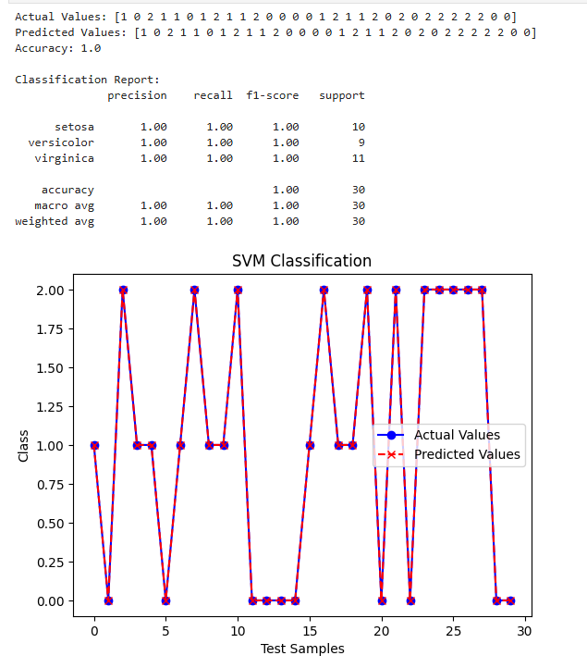

Aim: Implement and demonstrate k-nearest Neighbor algorithm. Read the training data from a
.CSV file and build the model to classify a test sample. Print both correct and wrong
predictions.

import pandas as pd
from sklearn.neighbors import KNeighborsClassifier
from sklearn.model_selection import train_test_split
from sklearn.metrics import accuracy_score

# Create sample dataset and save it as a CSV file
data = {
'Height': [150, 160, 170, 180, 155, 165, 175, 185, 152, 178],
'Weight': [50, 55, 65, 80, 52, 60, 75, 85, 48, 78],
'Class': ['A', 'A', 'B', 'B', 'A', 'A', 'B', 'B', 'A', 'B']
}

df = pd.DataFrame(data)
df.to_csv('data.csv', index=False)

# Read training data from CSV file
df = pd.read_csv('data.csv')

X = df[['Height', 'Weight']]
y = df['Class']

# Split data into training and testing sets
X_train, X_test, y_train, y_test = train_test_split(
X, y, test_size=0.3, random_state=42
)

# Build KNN model
model = KNeighborsClassifier(n_neighbors=3)
model.fit(X_train, y_train)

# Predict test samples
y_pred = model.predict(X_test)

# Print correct and wrong predictions
print("Actual\tPredicted\tResult")

for actual, predicted in zip(y_test, y_pred):
if actual == predicted:
print(actual, "\t", predicted, "\t\tCorrect")
else:
print(actual, "\t", predicted, "\t\tWrong")

# Print accuracy
print("\nAccuracy:", accuracy_score(y_test, y_pred))

